AgentCubed FHCP
Training Guide

Lesson 1 – Welcome to AgentCubed ……………………………….......... 3
Lesson 2 – AgentCubed Login …………………… 4
Lesson 3 – AgentCubed Location Login …………………… 6
Lesson 4 – Entering a New Lead from Leads Tab …………………. 7
Lesson 5 – Navigating the Assigned Leads Tab………………….. 9
Lesson 6 – Entering Leads from My Dashboard Tab………………….. 10
Lesson 7 – Navigating the My Dashboard Tab………………….. 11
Lesson 8 – Password Reset ………………………………………………. 13

Lesson 1 – Welcome To AgentCubed

The purpose of this document is to provide a high-level process overview that should aid users in navigating AgentCubed. AgentCubed is a lead management platform designed to track and manage leads from creation to sale.

Florida Blue is asking all sales channels that are recipients of Medicare marketing leads to utilize AgentCubed to record lead activity.

Key Features of AgentCubed:
- Optimizing sales through full life of lead transparency
- Agent calendar view
- Real time updates and the ability to manage leads across all channels supporting customer channel of choice
- Increased sales conversion
- Client policy management
- Improved adherence to regulatory laws and compliance policies

Lesson 2 – AgentCubed Login

Each user will receive an email similar to the below image once an account is created. The Username will be listed within the email along with a link for the user to create a password. Once this link is selected it will no longer work. For future logins go to: https://portal.agentcubed.com
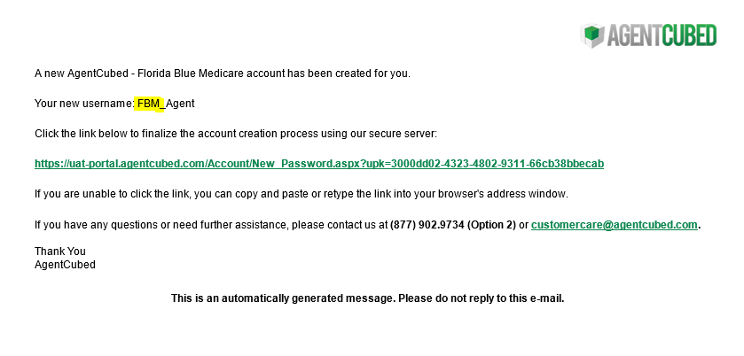
Once the link is clicked in the new user email, the user is prompted to enter a new password.
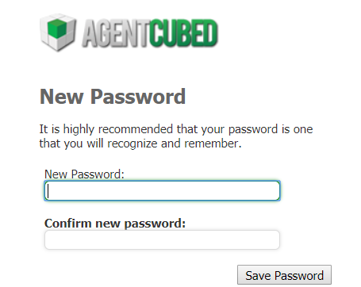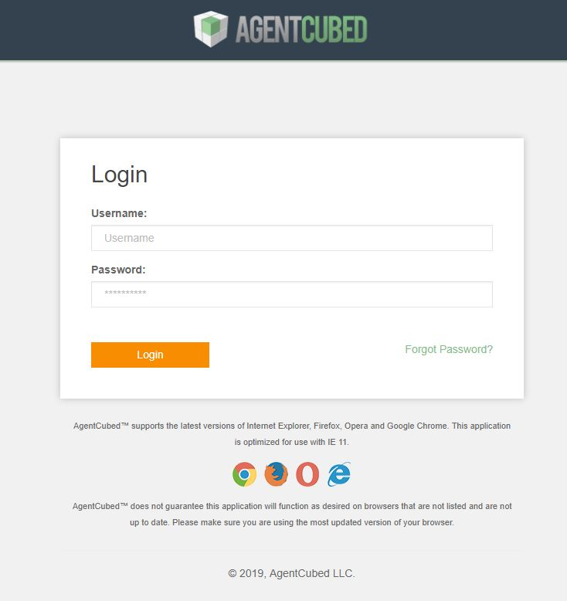

Once password is created and the user logins into the system for the first time, the user is asked to verify their account information in AgentCubed. Once verified, the user is logged into AgentCubed.
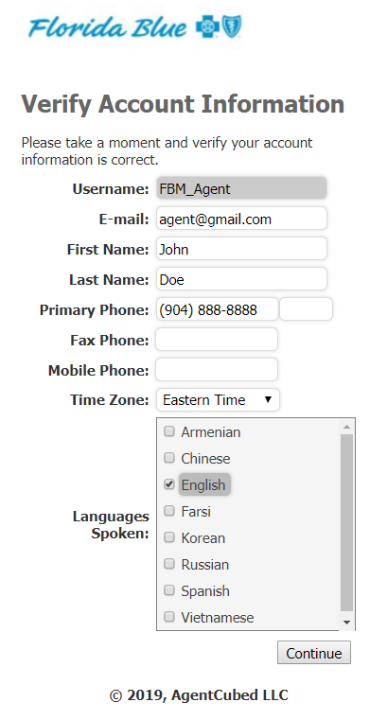

Lesson 3 – AgentCubed Location Login
Certain users in AgentCubed will be prompted to select a physical location before they can access AgentCubed. Begin typing to find your location.
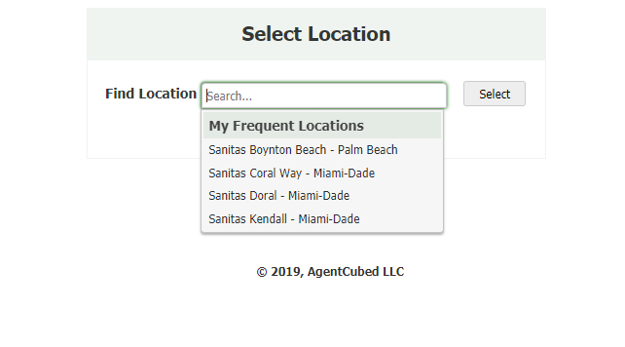

Once logged in, a user can change their location if needed by clicking on the location name at the top right.

Lesson 4 – Entering a New Lead from Leads Tab

When entering a new lead into AgentCubed, the user will click the LEADS header at the top of the screen and then click NEW CUSTOMER.
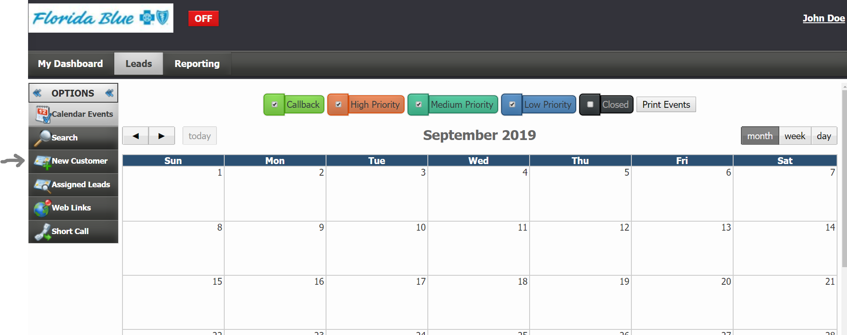
Once on the NEW CUSTOMER page, first step is to click FHCP in the MASTER SOURCE dropdown. Once FHCP is selected, only the FHCP sources will be available in the Source dropdown and the Insurance Type will display Medicare when Source is selected. Sources are equivalent to marketing campaigns.
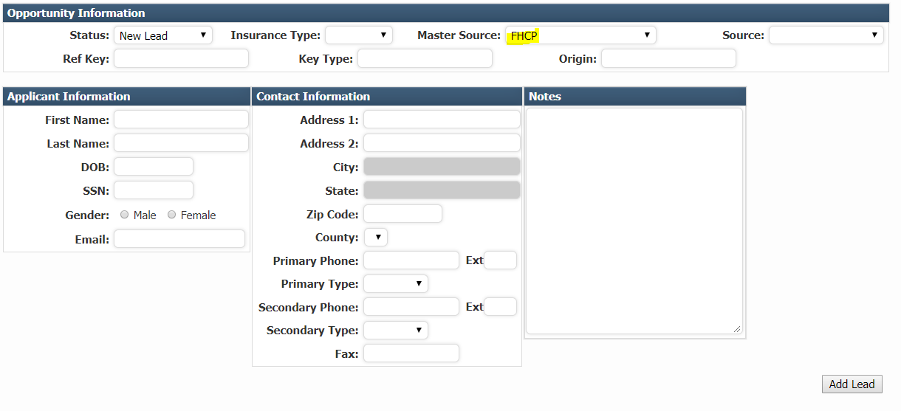
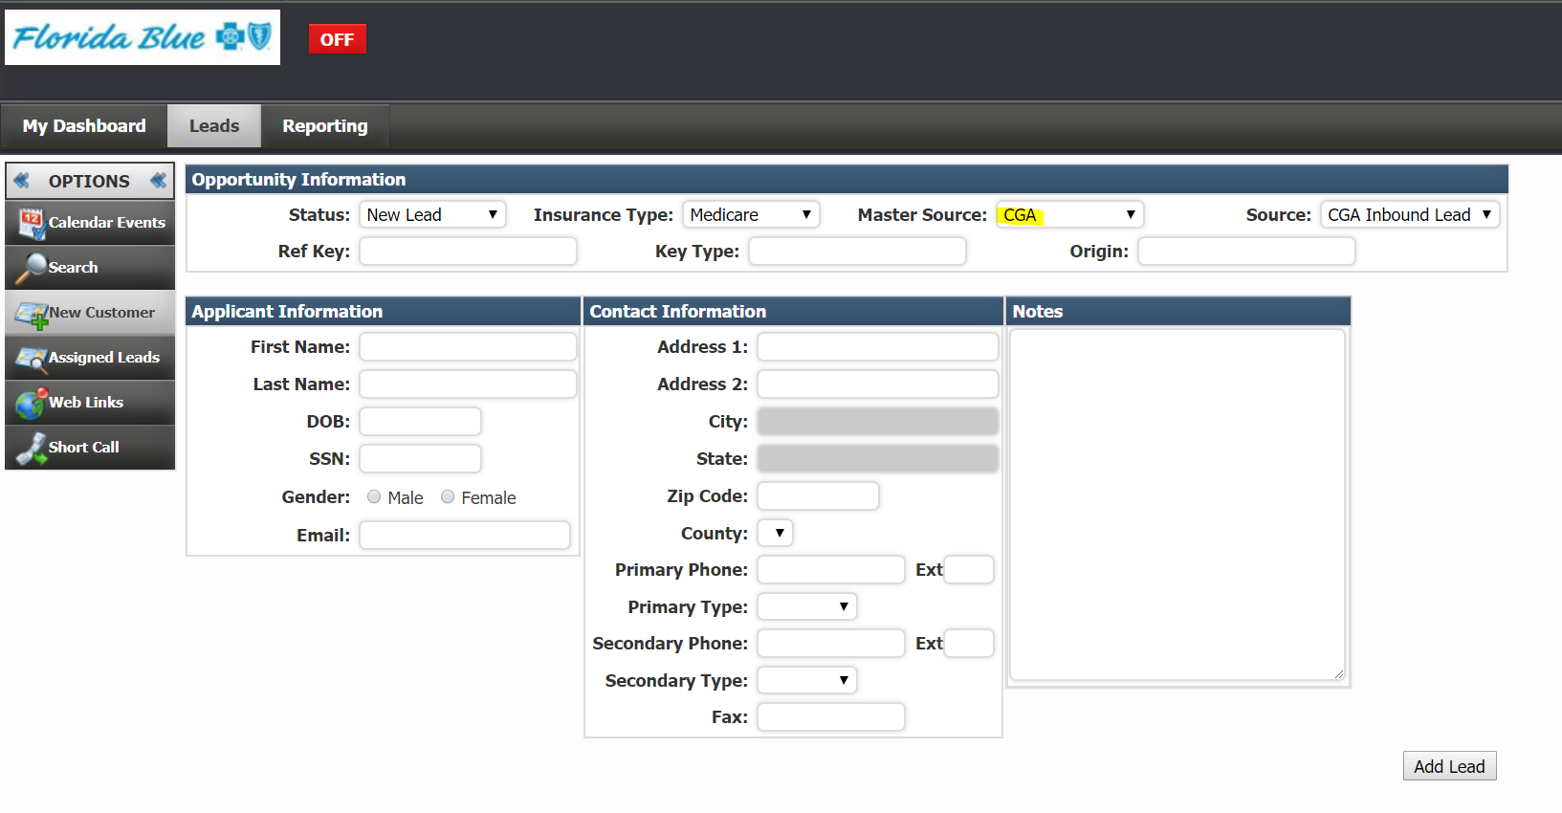

To Add Lead on the NEW CUSTOMER page, First Name, Last Name, Zip Code and Primary Phone must be populated. Enter as much additional contact information as is available.
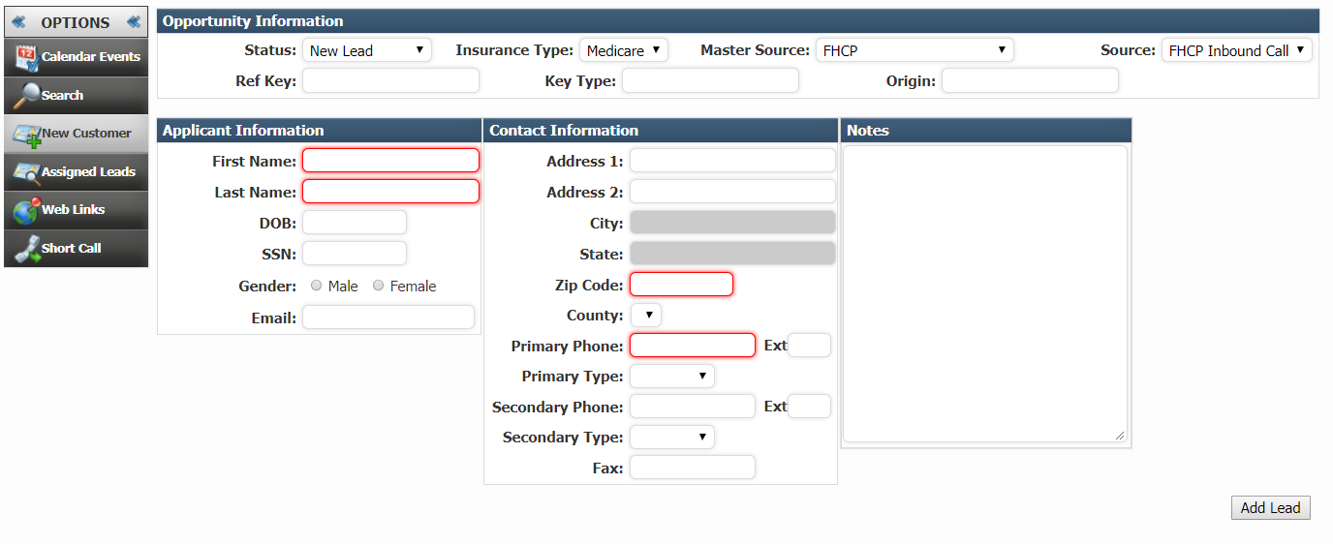
Once a new lead has been added, the lead record will open.
- If Consent to Contact button does not automatically show the ‘C2C – 90 Day(s)’, the user will need to either leave the Consent to Contact red ‘C2C – Consent Expired’ or if the user gained consent to contact they should click the red button and select Ok to turn the ‘C2C- 90 Day(s)’ on.
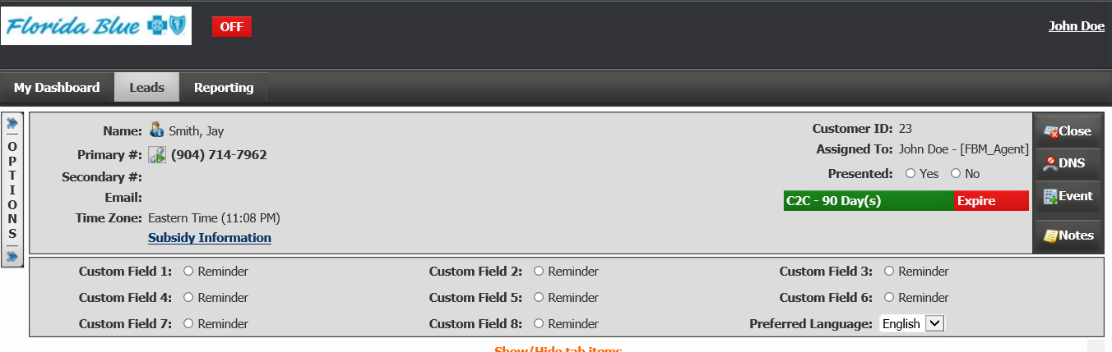
- User will need to select the Preferred Language of the lead.
- If notes are available, these should be entered in the Notes page located on the far right.
- And then click Close located on the top right.
- Select the appropriate Disposition.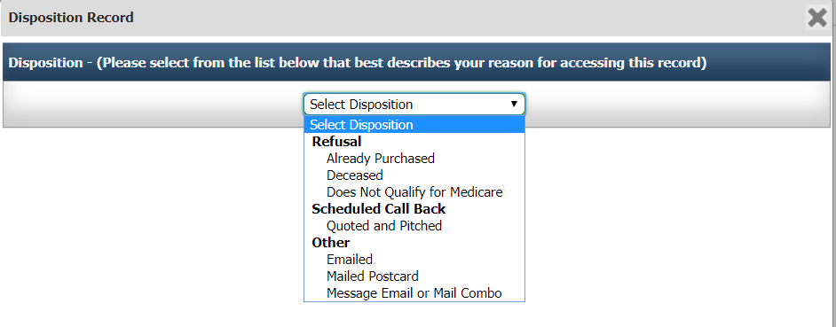

Lesson 5 – Navigating Assigned Leads Page
To view leads that have been added by you or assigned to you, click Leads – Assigned Leads. Click the gear icon next to My Assigned Leads in the blue bar.

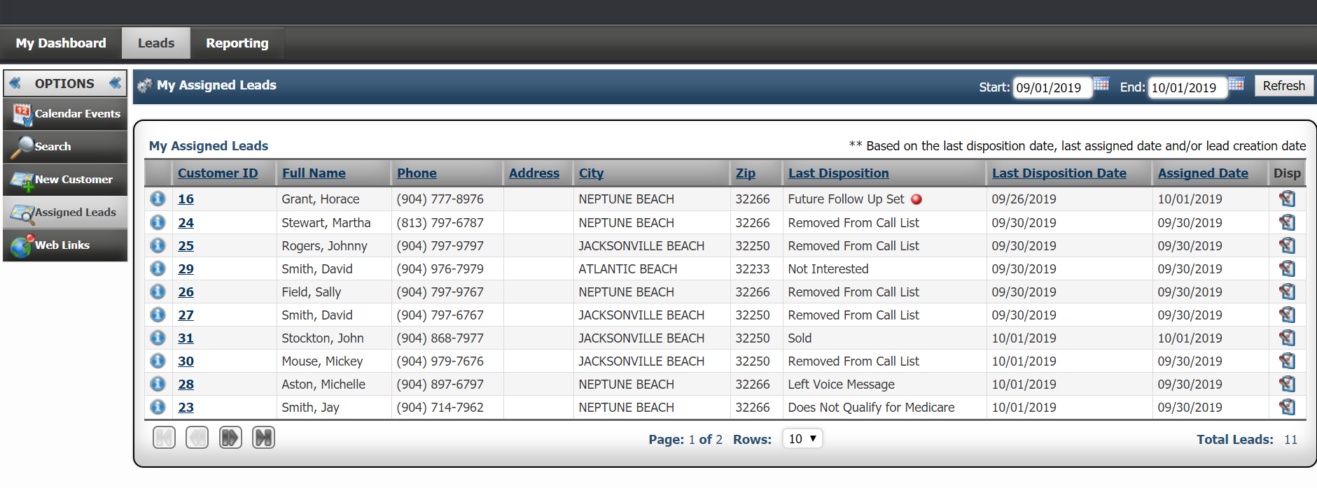

Select values to filter by and click Refresh to see those settings take effect. Click Save Settings if you would like to always have this view.

We recommend looking at Last Disposition Type – Agency Call Back at least once a day. These would be disposition types that indicate the lead is still “workable”.

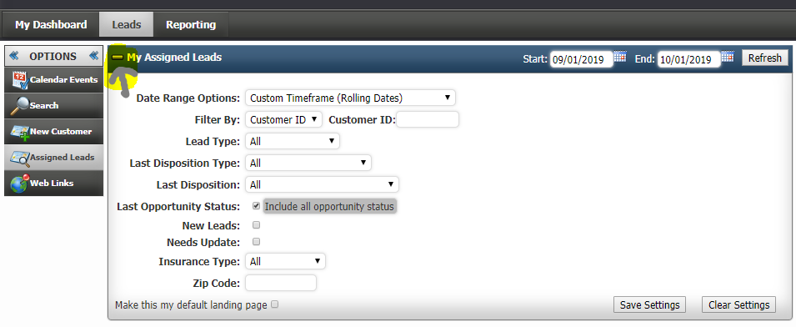

Disposition the leads by clicking the icon on the far right.

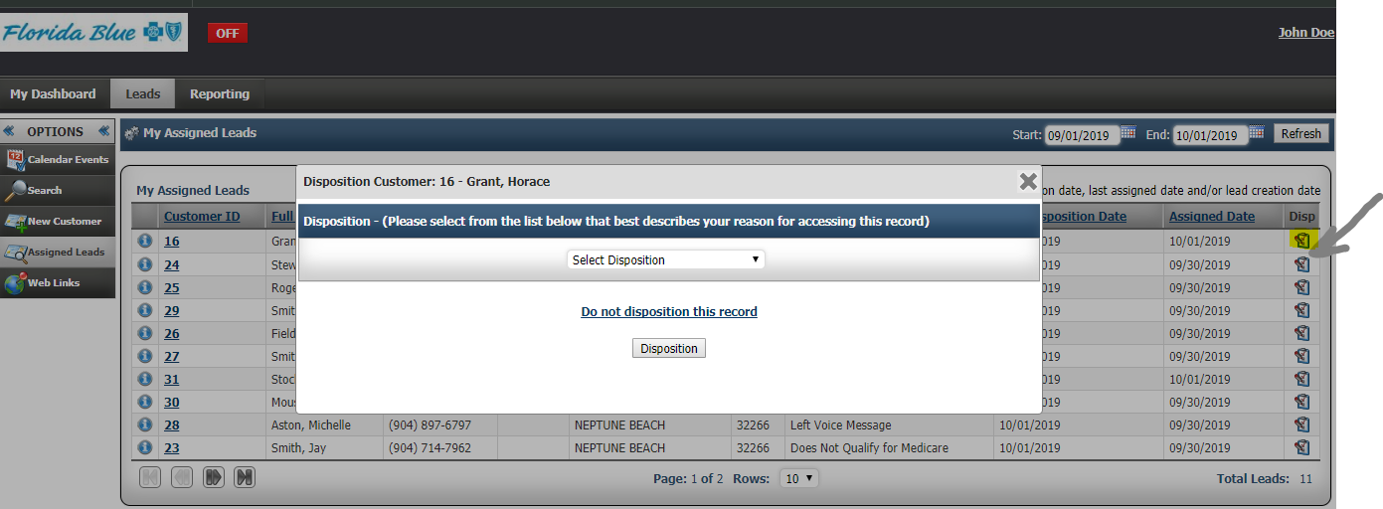

Lesson 6 – Entering a New Lead from My Dashboard Tab
To add lead from My Dashboard tab click on Add Lead on the top left. The lead form will have the same requirements as the lead form in Lesson 4.
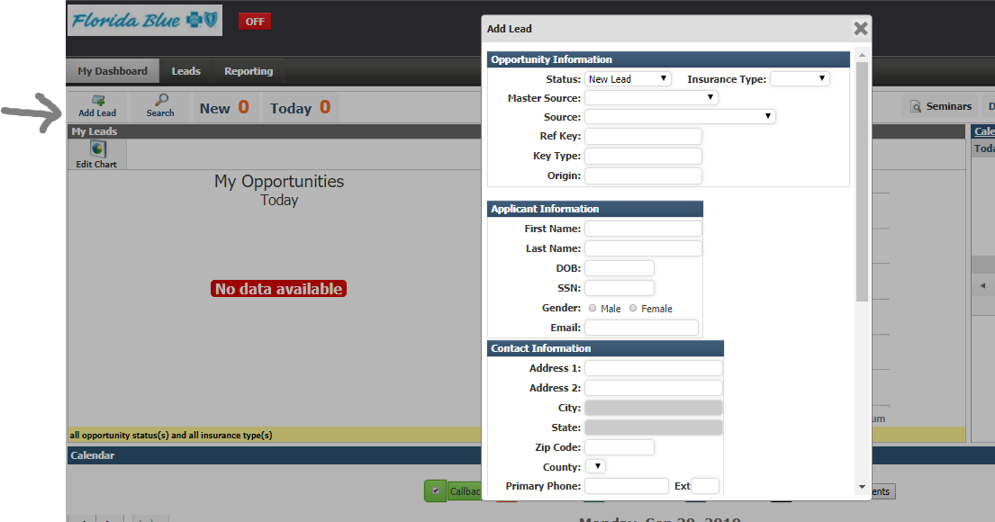
Once the lead is added, user has the option to Open Lead, Create another Lead, or Close Window. If select “Open Lead” the customer record will open. If select “Create another Lead”, the lead form in the above screenshot will open so the user can add additional leads.
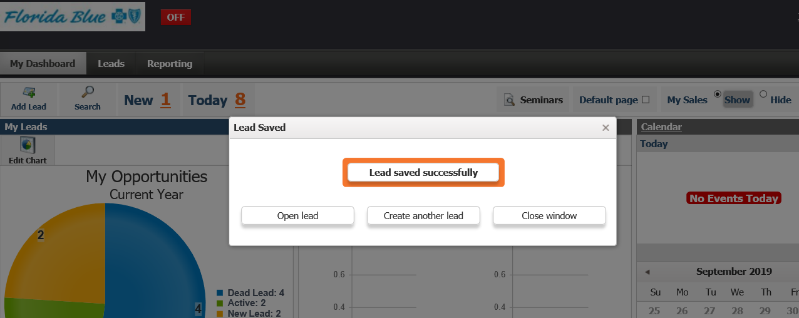

Lesson 7 – Navigating the My Dashboard
New number represents the number of leads assigned to the user’s account that the user has not personally dispositioned. The New number should be 0 by the end of each day. A CGA lead should not be in AgentCubed that does not have a disposition.
Today number represents how many leads were assigned to the user account today. This number includes leads created by the user.
When clicking either of those numbers, the leads will display at the bottom of the Dashboard.
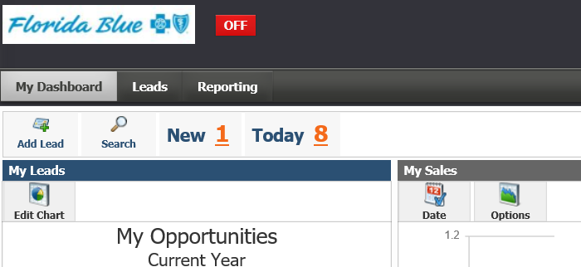

We recommend users Edit Chart, and select Current Year and Opportunity Status to create their pie chart filters.
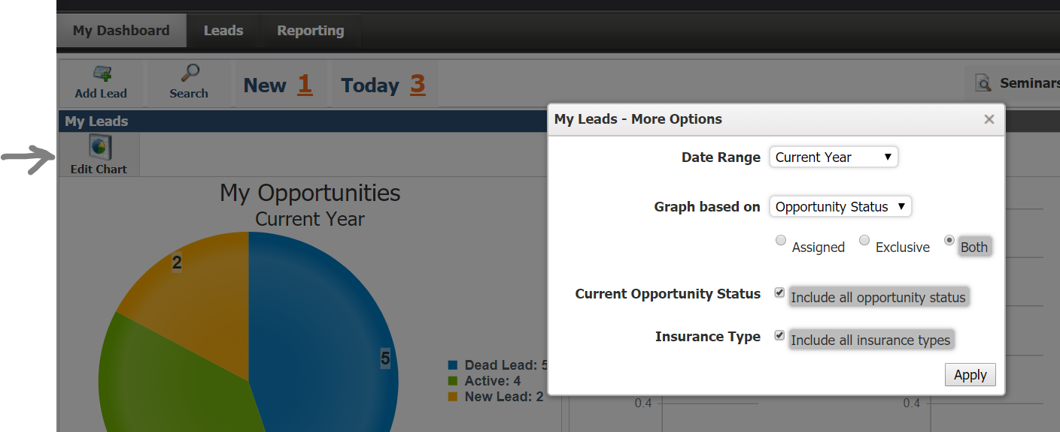

Then users can click on any portion of the pie chart to have the lead details displayed below the chart.

Leads displaying on the bottom of the My Dashboard. The leads displayed are based on what the user selected up top (e.g. New, Today, pie chart, etc.)
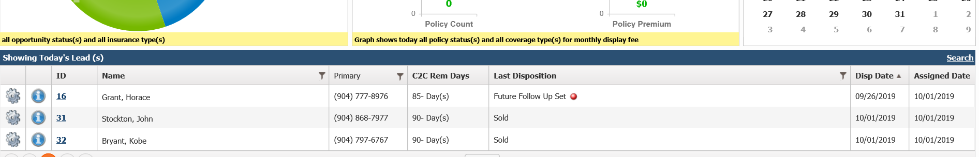
User click on the Last Disposition and the disposition pop up will display for the user to select an updated disposition. A red dot indicates the last time the lead was dispositioned it was not by the current assigned user. 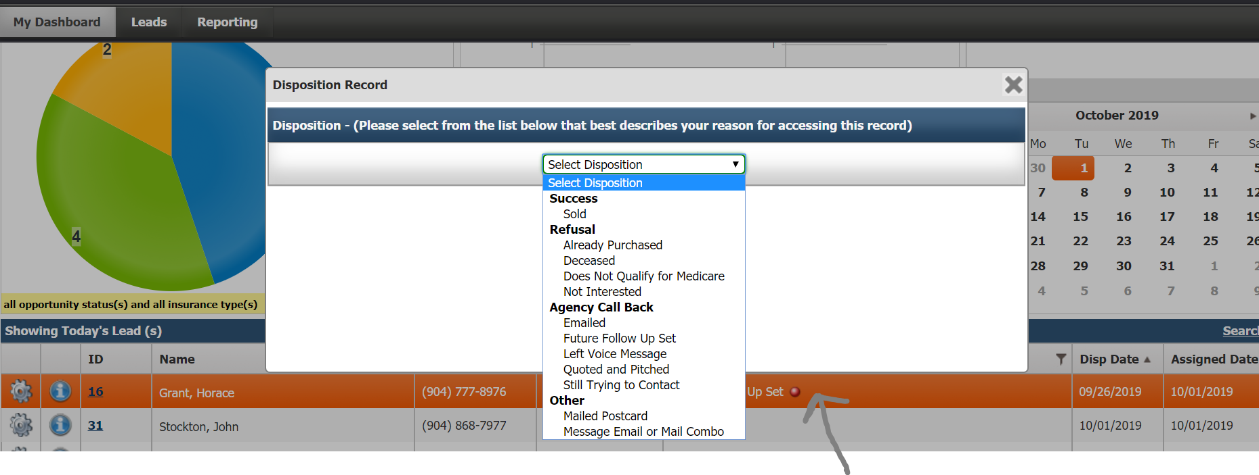

Lesson 8 – Password Reset
If the user has forgotten their password, they simply go to portal.agentcubed.com, click Forgot Password and follow the remainings instructions.
